PROJECT PLANNING PHASE
PRODUCT BACKLOG • SPRINT PLANNING • STORIES • STORY POINTS
Date
Team ID | SWTID-2026-3317 _________
Project Name | AI FAQ Assistant
Maximum Marks | 5 Marks

1. Product Backlog, Sprint Schedule and Estimation
Sprint | Functional Requirement (Epic) | User Story Number | User Story / Task | Story Points | Priority | Team Members
Sprint-1 | Registration | USN-1 | As a user, I can register for the application by entering my email, password and confirming my password. | 2 | High | Team
Sprint-1 | Registration | USN-2 | As a user, I will receive confirmation after successful registration. | 1 | High | Team
Sprint-1 | Login | USN-3 | As a user, I can log into the application by entering email and password. | 1 | High | Team
Sprint-1 | Authentication | USN-4 | As a user, I can securely access the application after authentication. | 2 | High | Team
Sprint-1 | FAQ Management | USN-5 | As a user, I can view frequently asked questions and answers. | 3 | High | Team
Sprint-1 | FAQ Management | USN-6 | As a user, I can ask a question using the chat interface. | 3 | High | Team
Sprint-2 | AI Assistant | USN-7 | As a user, I can receive a relevant AI-generated response to my question. | 3 | High | Team
Sprint-2 | AI Assistant | USN-8 | As a user, I can enter natural-language questions. | 2 | High | Team
Sprint-2 | Admin | USN-9 | As an admin, I can add new FAQ questions and answers. | 2 | High | Team
Sprint-2 | Admin | USN-10 | As an admin, I can update or delete existing FAQs. | 2 | Medium | Team
Sprint-3 | Testing & UI | USN-11 | As a user, I can receive a clear response for an unknown question. | 2 | Medium | Team
Sprint-3 | Testing & UI | USN-12 | As a user, I can log out securely from the application. | 1 | Medium | Team
Sprint-3 | Testing & UI | USN-13 | As a user, I can use the application through a simple and responsive interface. | 2 | Medium | Team
Sprint-3 | Testing & Deployment | USN-14 | As a project team, we can test the major positive and negative scenarios. | 2 | High | Team
Sprint-3 | Testing & Deployment | USN-15 | As a project team, we can prepare the application for deployment and demonstration. | 1 | Medium | Team

2. Project Tracker, Velocity & Burndown Chart
Sprint | Total Story Points | Duration | Sprint Start Date | Sprint End Date (Planned) | Story Points Completed | Sprint Release Date (Actual)
Sprint-1 | 12 | 6 Days | 15 Feb 2025 | 20 Feb 2025 | 12 | 20 Feb 2025
Sprint-2 | 12 | 6 Days | 21 Feb 2025 | 26 Feb 2025 | 12 | 26 Feb 2025
Sprint-3 | 8 | 6 Days | 27 Feb 2025 | 04 Mar 2025 | 8 | 04 Mar 2025

3. Velocity Calculation
Example: If a sprint has 10 working days and the team completes 20 story points, the average velocity per day is 20 ÷ 10 = 2 story points/day.
For this project, Sprint-1 has 12 story points over 6 days. Average sprint velocity = 12 ÷ 6 = 2 story points/day.

4. Burndown Chart
The burndown chart shows the amount of work remaining during Sprint-1. The ideal line reaches zero at the end of the sprint, while the actual line represents remaining story points.
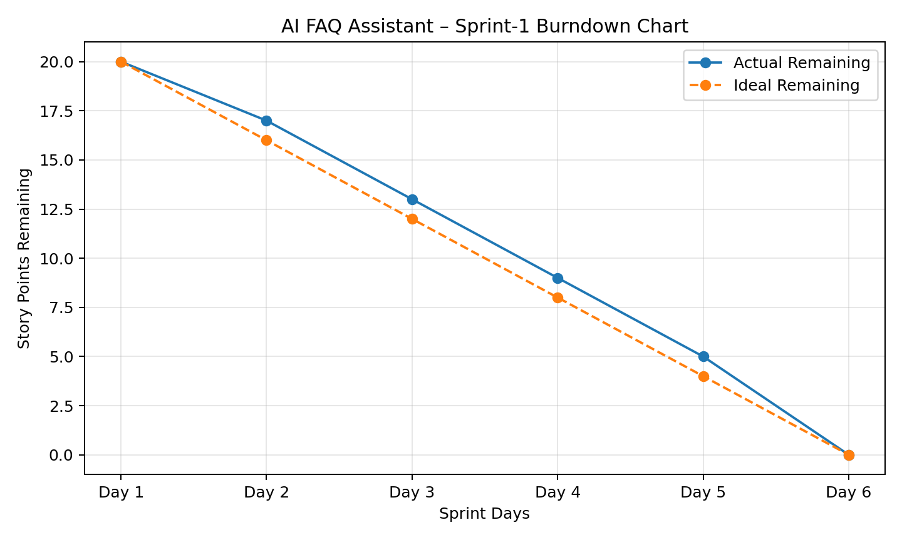

Note: Replace “Team” with your actual team member names and update the dates if your faculty has assigned different sprint dates.

